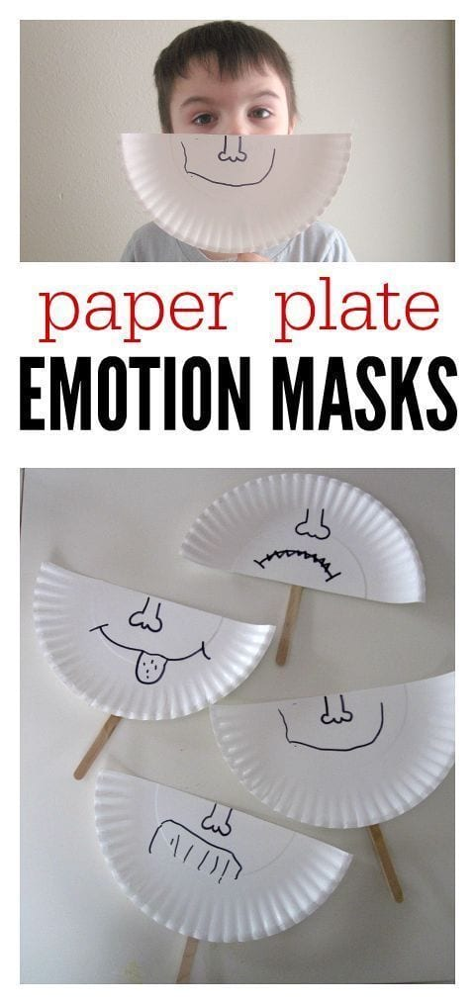

This activity can also be done using simple paper and marker if paper plates are not available. Straws can also be substituted for popsicle sticks or whatever else you may have around your home.

**Activity**: Cut the paper plate or paper in half and have your child (with your help if necessary) draw an emotion face to the best of your ability. For younger students (3 year olds) keep emotions simple such as happy and sad. For older students (4+) emotions can be more complex such as angry, happy, excited, disappointed, excited, or worried.

You or others in your household can play a simple game with your child by having the child identify each emotion in a fun way (Example: hiding it behind your back then whipping it to the front while they call out the emotion names). Use this opportunity to discuss emotions with your child. You can lead off the conversation by describing how emotions affect you. “I feel sad when it rains and we can’t go to the park” “I feel happy when you eat all of your vegetables”. You can then ask your child to do the same by telling you or showing you by pointing if necessary.

**(Provided by PIRS:** Susan Monfet, Barbara Berger, Janice Torres, Simone Smith**)**